CIS 476 – Term Project
Name: Aldo Medina, Rania Dayekh
Date: 12 April 2026

1. Introduction
DriveShare is a peer-to-peer car rental platform that allows users to register, log in, list vehicles, search for cars, create bookings, send messages, receive notifications, complete simulated payments, and review past rental activity. The project applies multiple design patterns to improve modularity, communication between components, and maintainability.

2. Class Diagrams and Descriptions

Builder Pattern – Car Listing Construction
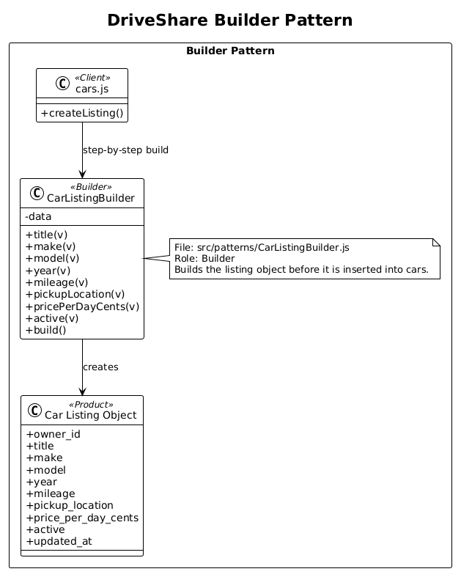
This diagram illustrates the Builder pattern used to create car listing objects. The client builds a listing step by step through the CarListingBuilder, setting fields such as title, make, model, year, mileage, pickup location, and daily price before producing the final object. This improves readability and keeps listing construction organized.

Chain of Responsibility Pattern – Password Recovery
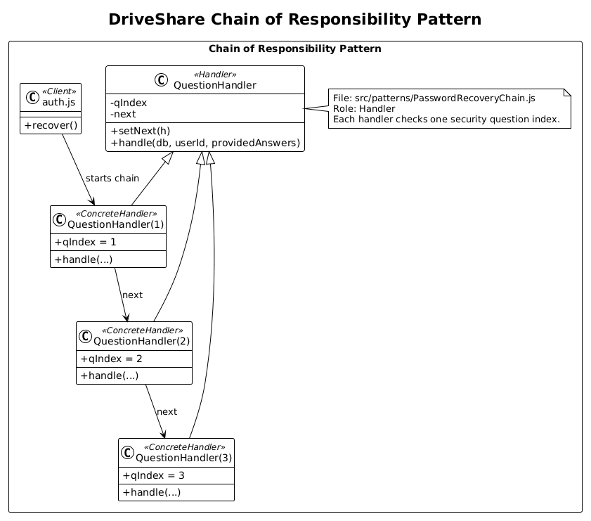
This diagram represents the Chain of Responsibility pattern used for password recovery. Each question handler checks one security question, and the request moves through the chain until all answers are validated or one fails. This separates each validation step and keeps the recovery flow modular.

Mediator Pattern – Search Coordination
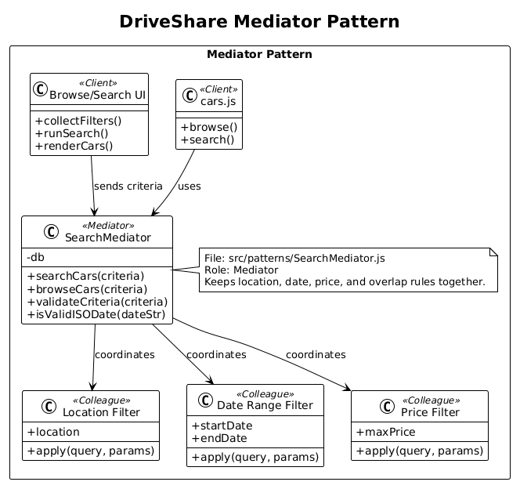
This diagram demonstrates the Mediator pattern used in search. The SearchMediator coordinates location, date, and price filtering so that the different search concerns are handled in one central place instead of being tightly coupled across multiple components.

Observer Pattern – Notifications System
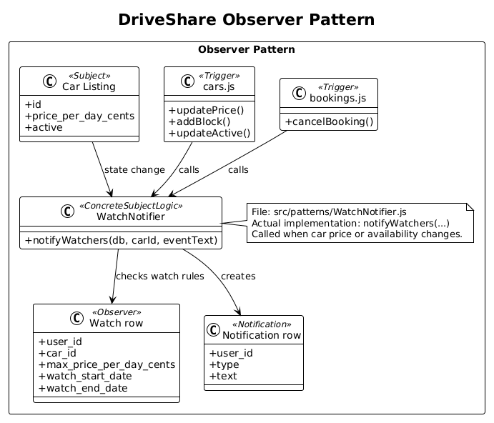
This diagram shows the Observer pattern used in the watch and notification system. When a car listing changes in price or availability, the system checks active watches and creates notifications for users whose conditions are met. This supports automatic updates without direct coupling between cars and renters.

Proxy Pattern – Payment Processing
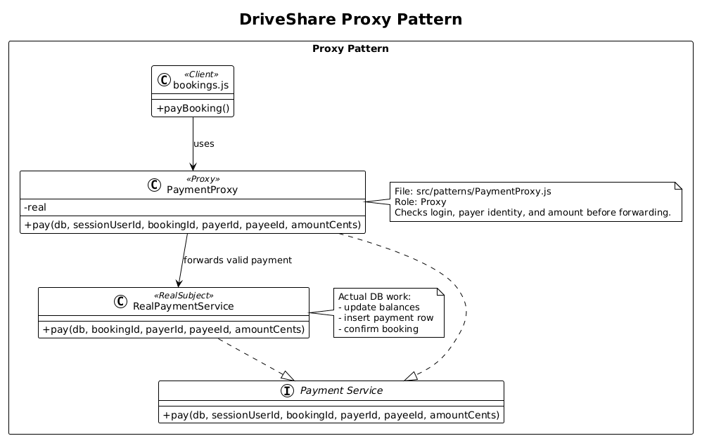
This diagram illustrates the Proxy pattern used for payment. The PaymentProxy checks the payer, payee, booking status, and amount before delegating the transaction to the real payment service. This adds protection and validation around payment processing.

Singleton Pattern – Session Management
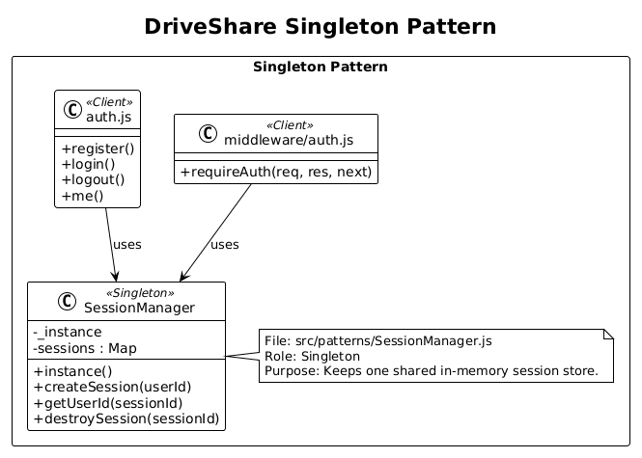
This diagram represents the Singleton pattern used for session management. The SessionManager provides one shared session store for authentication so that routes and middleware all use the same source of truth for logged in users.

3. Database Schema and Descriptions
The DriveShare database is implemented in SQLite and is designed to support user accounts, password recovery, car listings, bookings, availability blocks, watches, notifications, messages, payments, and reviews. The schema uses primary keys, foreign keys, required fields, unique constraints, and indexes to preserve data integrity and support the main owner and renter workflows.

Users Table
Column | Type | Description
id | Integer, primary key | Unique identifier for each user
email | Text, required, unique | Login email for the user
password_hash | Text, required | Stored hashed password
display_name | Text, required | Name shown in the interface
balance_cents | Integer, required | Simulated account balance used in payment flow
created_at | Timestamp | Time the account was created
This table stores the core identity and account information for both owners and renters. It is referenced by many other features in the system, including listings, bookings, messages, watches, notifications, payments, and reviews.

Security Questions Table
Column | Type | Description
id | Integer, primary key | Unique identifier for each question row
user_id | Integer, foreign key to Users | User who owns the question
q_index | Integer, required | Question order in the recovery chain
question_text | Text, required | Text of the security question
answer_hash | Text, required | Stored hashed answer
This table supports the password recovery feature. Each user stores three questions, and the q_index field allows the chain of handlers to verify answers in sequence.

Cars Table
Column | Type | Description
id | Integer, primary key | Unique identifier for each car listing
owner_id | Integer, foreign key to Users | User who owns the listing
title | Text, required | Short title used in the listing
make | Text, required | Vehicle manufacturer
model | Text, required | Vehicle model
year | Integer, required | Model year
mileage | Integer, required | Mileage shown in the UI
pickup_location | Text, required | Pickup location for the car
price_per_day_cents | Integer, required | Daily rental price in cents
seed_tag | Text, optional | Optional tag used for seeded data
active | Integer, required | Indicates whether the listing is active
created_at | Timestamp | Time the listing was created
updated_at | Timestamp | Time the listing was last updated
This table stores all owner-created car listings. It aligns with the Builder pattern because listing values are assembled before being inserted into this table.

Bookings Table
Column | Type | Description
id | Integer, primary key | Unique identifier for each booking
car_id | Integer, foreign key to Cars | Booked car
renter_id | Integer, foreign key to Users | User who created the booking
start_date | Date text, required | Requested rental start date
end_date | Date text, required | Requested rental end date
status | Text, required | Current booking state such as pending, confirmed, or cancelled
total_cents | Integer, required | Total price of the booking
created_at | Timestamp | Time the booking was created
This table stores reservations and connects renters to cars for a date range. It is central to availability checking, payment confirmation, and rental history.

Availability Blocks Table
Column | Type | Description
id | Integer, primary key | Unique identifier for each block
car_id | Integer, foreign key to Cars | Car being blocked
start_date | Date text, required | Start of blocked period
end_date | Date text, required | End of blocked period
reason | Text, optional | Optional owner reason for the block
created_at | Timestamp | Time the block was created
This table stores blackout periods for a car. It prevents bookings during owner defined unavailable dates and works together with confirmed bookings to control the calendar.

Watches Table
Column | Type | Description
id | Integer, primary key | Unique identifier for each watch
user_id | Integer, foreign key to Users | User watching the car
car_id | Integer, foreign key to Cars | Watched car
max_price_per_day_cents | Integer, optional | Target price for notifications
watch_start_date | Date text, optional | Desired start date
watch_end_date | Date text, optional | Desired end date
created_at | Timestamp | Time the watch was created
This table supports the Observer pattern. Each row acts like a subscription showing that a user wants updates about a specific car under optional price and date conditions.

Notifications Table
Column | Type | Description
id | Integer, primary key | Unique identifier for each notification
user_id | Integer, foreign key to Users | User receiving the notification
type | Text, required | Category such as booking, payment, message, or review
text | Text, required | Message shown to the user
is_read | Integer, required | Read or unread status
created_at | Timestamp | Time the notification was created
This table stores the alerts shown in the notification inbox. It supports persistent tracking of watch updates, booking updates, messages, reviews, and payment-related events.

Messages Table
Column | Type | Description
id | Integer, primary key | Unique identifier for each message
car_id | Integer, foreign key to Cars | Car linked to the conversation
owner_id | Integer, foreign key to Users | Owner participating in the conversation
renter_id | Integer, foreign key to Users | Renter participating in the conversation
sender_id | Integer, foreign key to Users | Actual sender of the message
body | Text, required | Message content
is_read | Integer, required | Read or unread status
created_at | Timestamp | Time the message was sent
This table supports communication between owners and renters while keeping the discussion connected to a specific car listing.

Payments Table
Column | Type | Description
id | Integer, primary key | Unique identifier for each payment
booking_id | Integer, foreign key to Bookings | Booking being paid for
payer_id | Integer, foreign key to Users | User making the payment
payee_id | Integer, foreign key to Users | User receiving the payment
amount_cents | Integer, required | Amount paid in cents
created_at | Timestamp | Time the payment was recorded
This table stores simulated payment transactions. It supports the Proxy pattern because payment requests are validated before the transaction is recorded and the booking is confirmed.

Reviews Table
Column | Type | Description
id | Integer, primary key | Unique identifier for each review
booking_id | Integer, foreign key to Bookings | Booking related to the review
reviewer_id | Integer, foreign key to Users | User writing the review
reviewee_type | Text, required | Whether the review is for a user or a car
reviewee_id | Integer, required | Identifier of the reviewed target
rating | Integer, required | Numeric score
comment | Text, optional | Optional review text
created_at | Timestamp | Time the review was created
This table supports rental feedback and history. It allows users to leave ratings and comments after bookings and connects reviews back to the relevant reservation.

4. User-Interface Screenshots and Descriptions

Login Screen
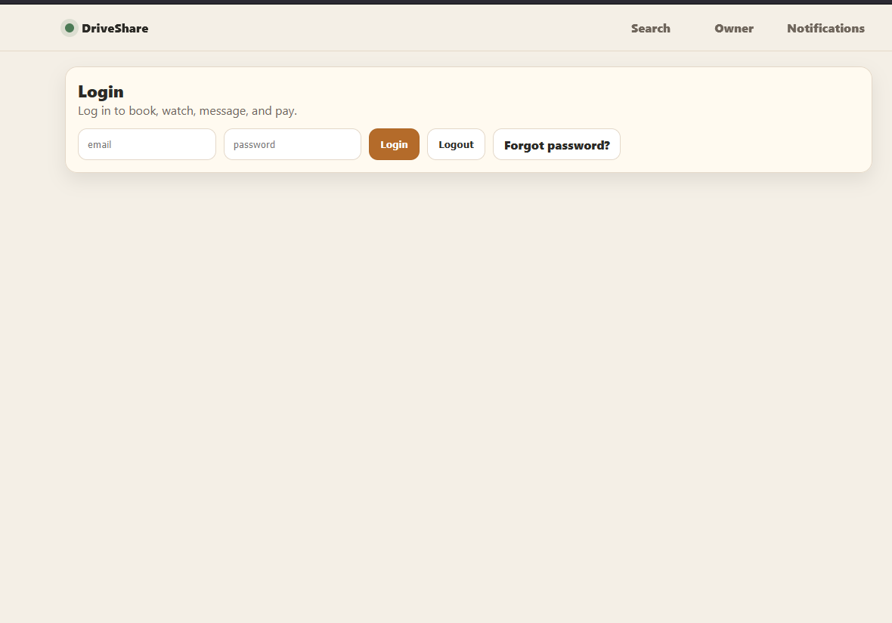
This screen allows a user to enter an email and password to log into the system. It also includes logout and password recovery access, making it the starting point for protected actions such as booking, watching cars, messaging, and payment.

Password Recovery Screen
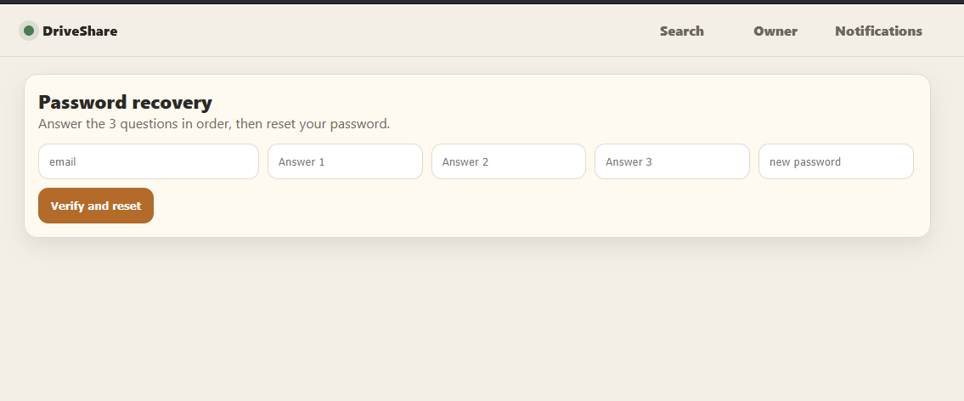
This screen supports password reset by asking the user to answer three security questions in order and then enter a new password. It directly reflects the Chain of Responsibility pattern used in the recovery flow.

Renter Search and Browse Screen
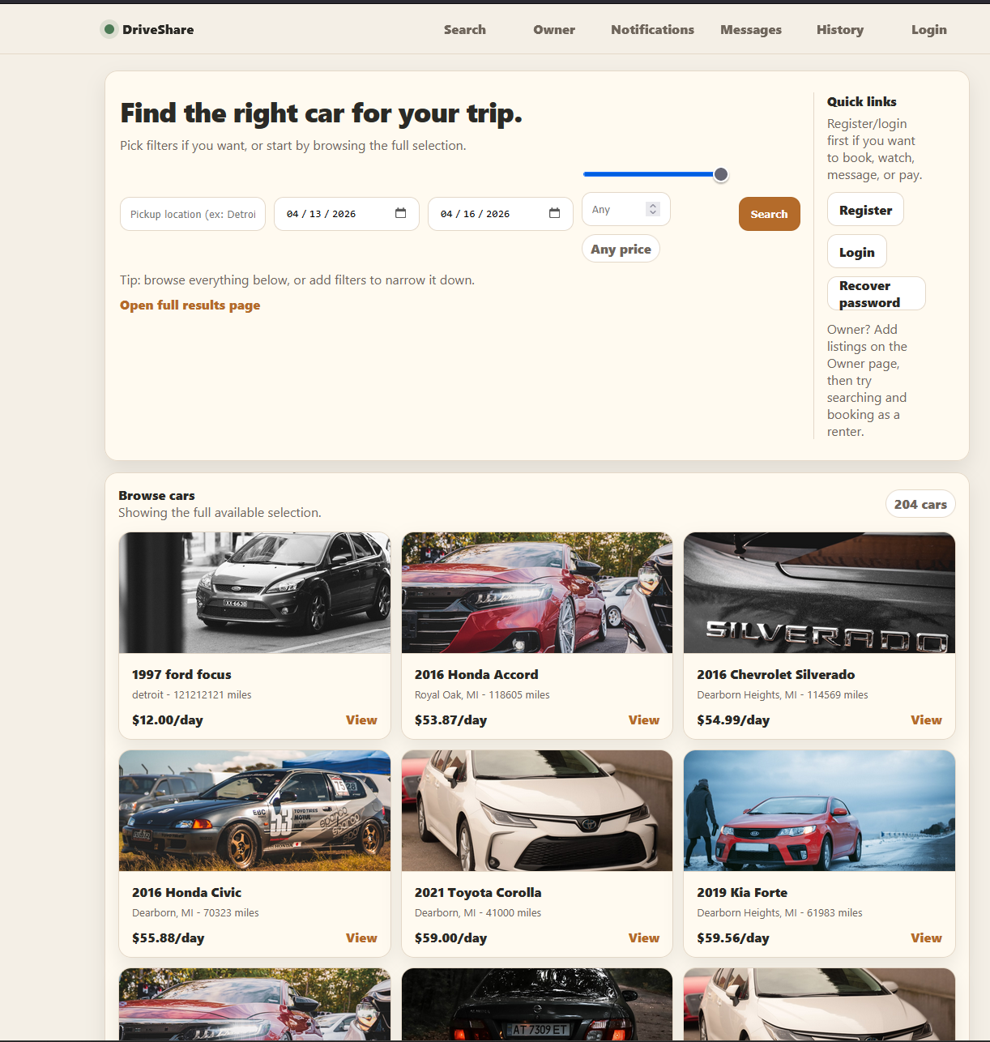
This screen is the main renter entry point for finding cars. It allows users to browse the inventory and apply filters such as pickup location, date range, and price so they can narrow down available listings.

Owner Dashboard Screen
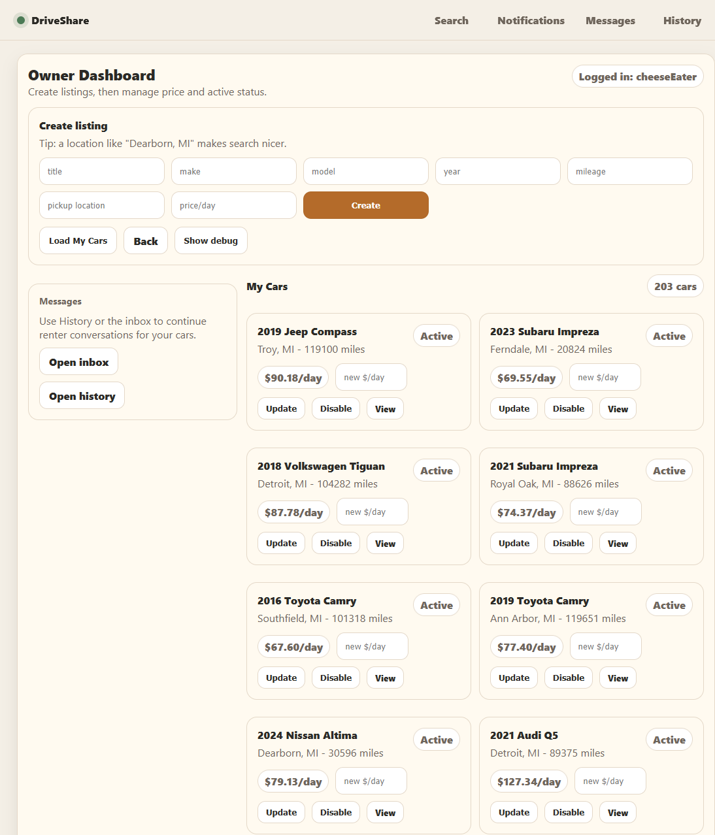
This screen allows owners to create new listings and manage existing ones. Owners can set listing details, update price information, change active status, and jump to related inbox or history views.

Car Details / Booking / Payment Screen
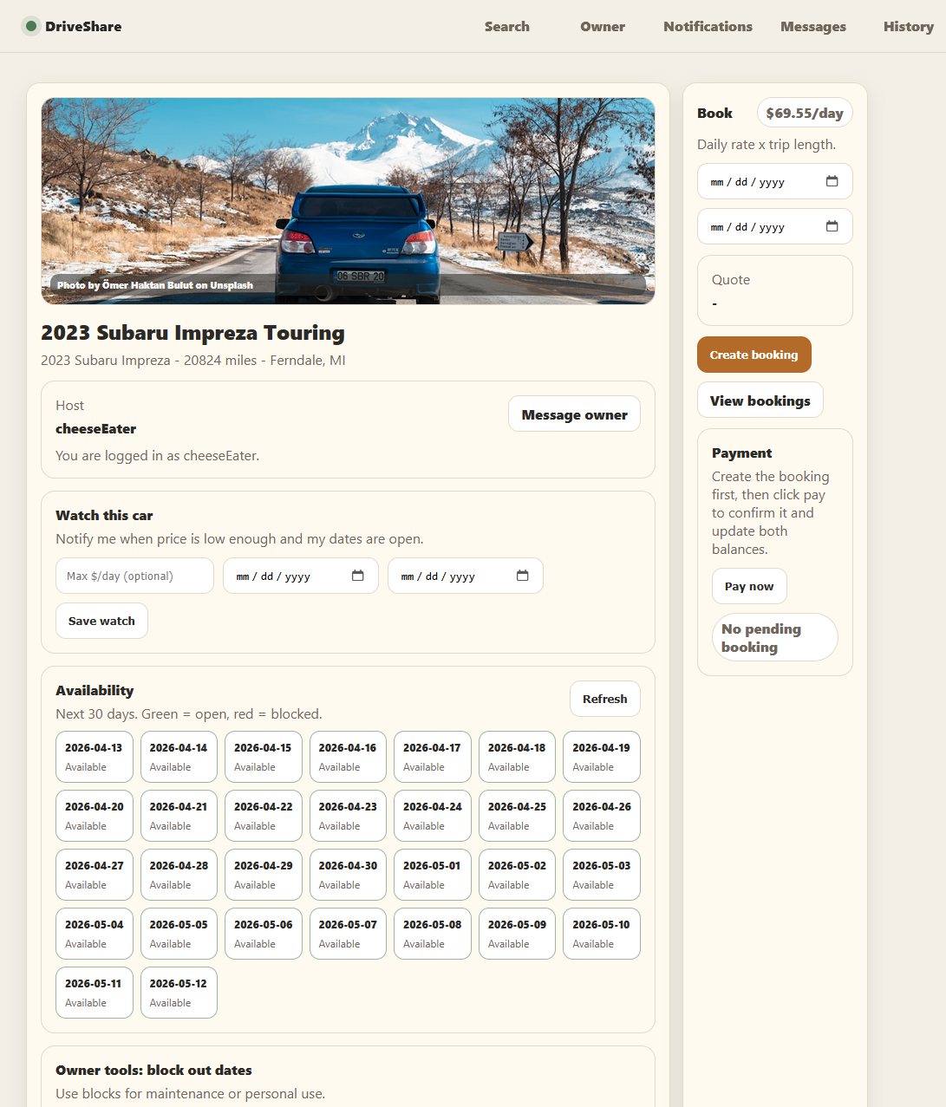
This screen combines several key renter and owner actions. It shows the selected car, host information, watch options, availability calendar, booking form, and payment area.

Notifications Screen
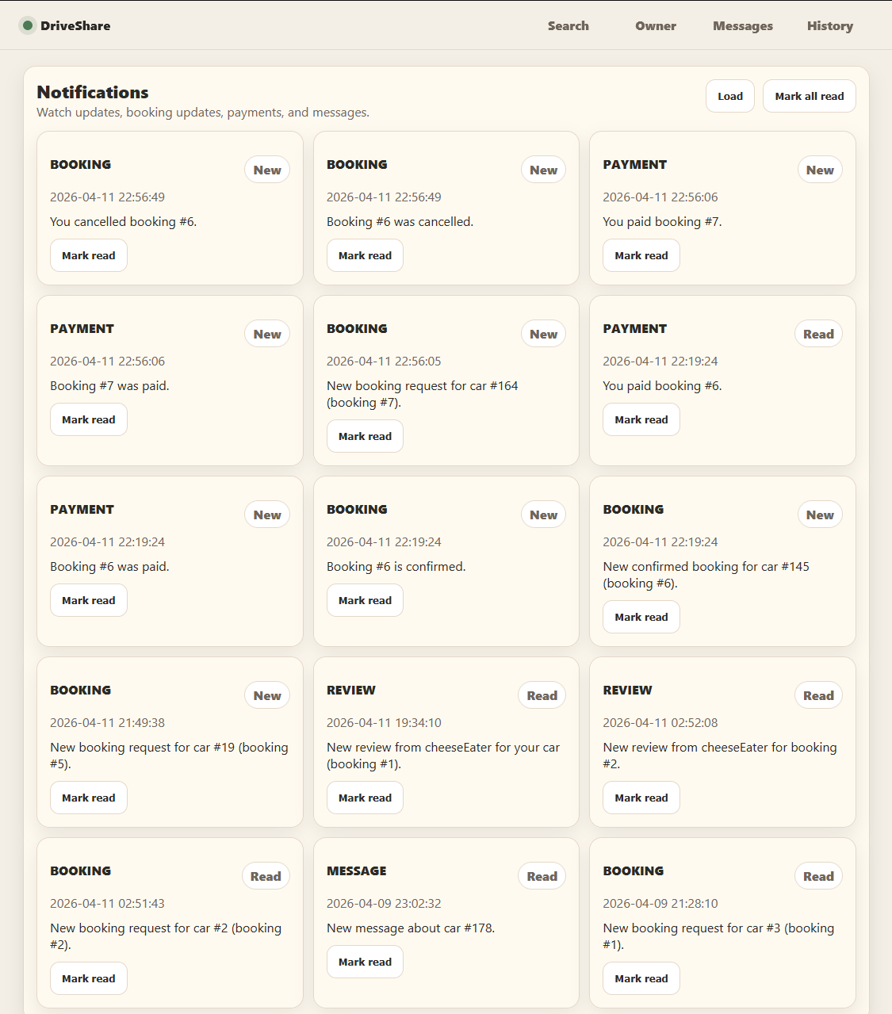
This screen displays the user’s notification inbox. It includes booking updates, payment updates, review alerts, and message alerts, showing how the system keeps users informed about important events.

Messages Screen
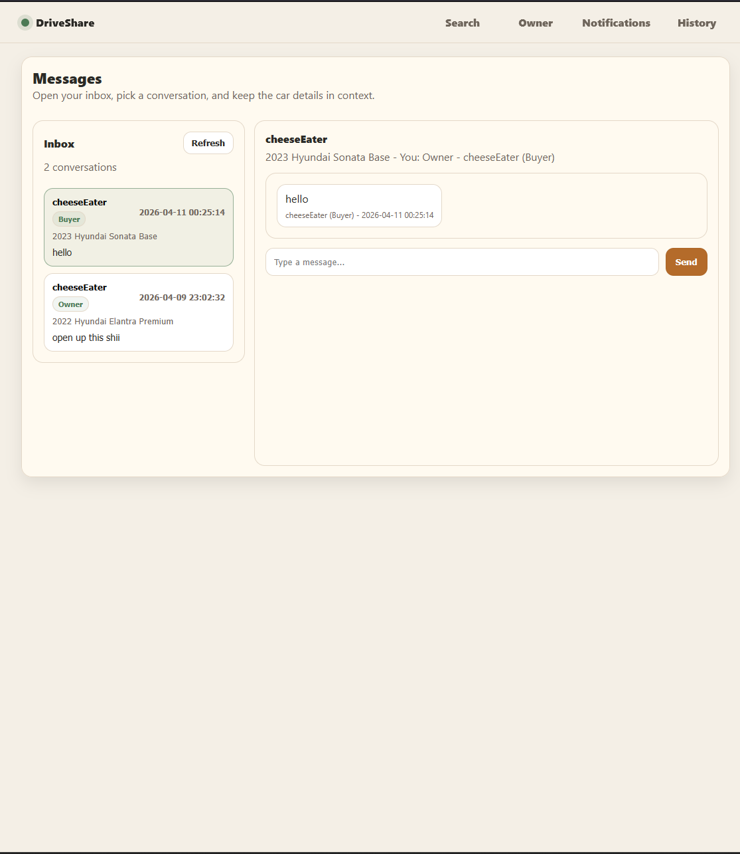
This screen shows the conversation interface between renters and owners. It keeps the relevant car context visible and allows both parties to send messages in a dedicated inbox view.

Rental History and Reviews Screen
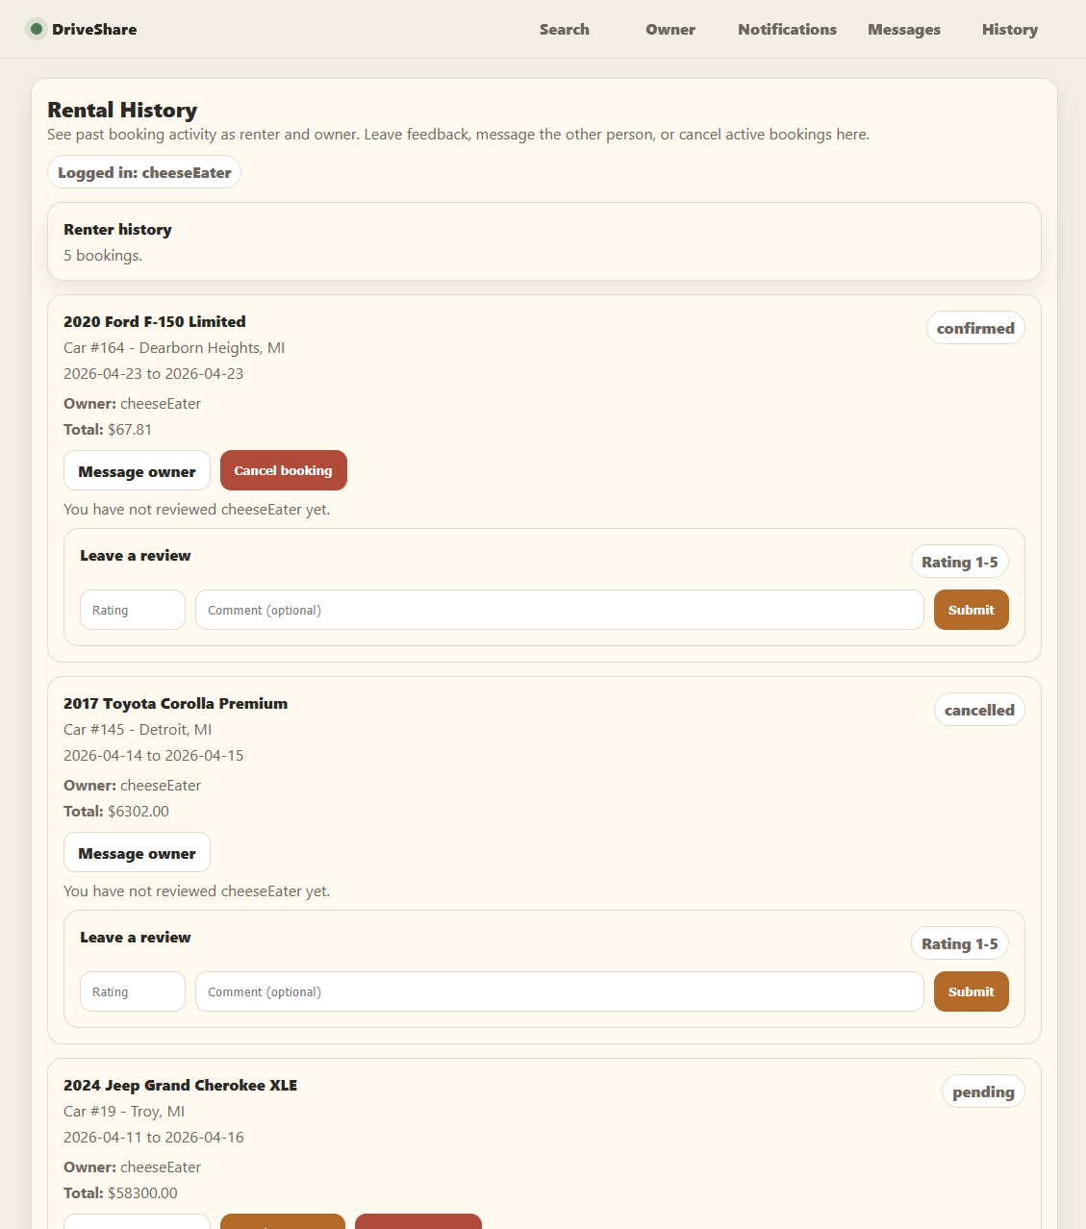
This screen displays past and active rental activity. It also allows users to cancel certain bookings, message the other party, and submit reviews, connecting the history feature with the review system.

5. References
- DriveShare GitHub repository and README.
- DriveShare SQLite schema file.
- Lecture materials on UML and design patterns.
- Design Patterns: Elements of Reusable Object-Oriented Software, Gamma et at., Richard Helm, Ralph Johnson, and John Vlissides Addison-Wesley
- Turo.com as a conceptual reference for peer-to-peer car rental.
- Unsplash.com for pictures.

